24W10LED PAR LIGHT(RGBW)
Product Introduction

reconized. The main control chip use the ARM inner singal chip (32 bit computing, 16 grade dimmer) which make the

Product Function Featrue

1. International DMX 512 protocal.
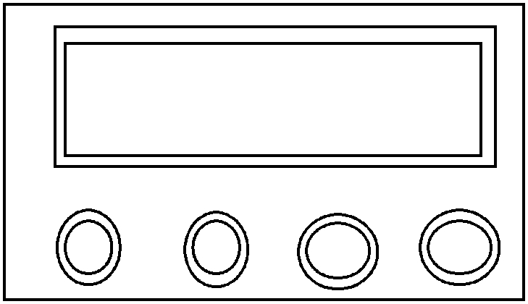
Button Specification

MENU: choose menu or back to previous menu.

UP: Choose menu or increase the parameter.

DOWN: choose menu or decrease the parameter.

ENTER: choose OK.

MENU UP DOWN ENTER

Menu Function

MENUSTAT | RED | (0～255)
 | GREEN | (0～255)
 | BLUE | (0～255)
 | WHITE | (0～255)
 | STROB | (0～20)
AUTO | AT.01 | (SP0～99)
 | AT.02 | (SP0～99)
 | AT.03 | (SP0～99)
 | AT.04 | (SP0～99)
 | AT.05 | (SP0～99)
 | AT.06 | (SP0～99)
 | AT.07 | (SP0～99)
 | AT.08 | (SP0～99)
 | AT.09 | (SP0～99)
 | AT.10 | (SP0～99)
DMX | D(001～512)
PERS | STAG
 | ARC.1
 | AC1.D
 | ARC.2
 | AC2.D
 | AC2.S
 | HSV
ID | D(01～66)
SET | REST | ＊＊＊＊
 | DSW | ON
 |  | OFF
 | BSW | ON
 |  | OFF
 | CURE | CUR0
 |  | CUR1
 |  | CUR2
 |  | CUR3
 | DIM | DIM0
 |  | DIM1
 |  | DIM2
 |  | DIM3
 |  | DIM4
CAL1 | RED | (25～255)
 | GREEN | (25～255)



 | BLUE | (25～255)
 | WHITE | (25～255)
KEY | ON
 | OFF
TEMP | 25℃
Menu Function Setting
1.Static Setting（STAT)
MENUSTAT | RED | (0～255)
 | GREEN | (0～255)
 | BLUE | (0～255)
 | WHITE | (0～255)
 | STROB | (0～20)
In the STAT menu, press ENTER into static mode, then press ENTER for R/G/B/W/ST, UP/DOWN for choosing, ENTER for

2.AUTORUN SETTING（AUTO）
AUTO | AT.01 | (SP0～99)
 | AT.02 | (SP0～99)
 | AT.03 | (SP0～99)
 | AT.04 | (SP0～99)
 | AT.05 | (SP0～99)
 | AT.06 | (SP0～99)
 | AT.07 | (SP0～99)
 | AT.08 | (SP0～99)
 | AT.09 | (SP0～99)
 | AT.10 | (SP0～99)

In the AUTO menu, press ENTRE in the AUTO menu into autorun mode, then UP/DOWN for choosing autorun mode,

3.ADDRESS CODE SETTING（DMX） DMX D(001～512)
back to previous menu. 4.Channel Mode（PERS）

PERS STAG ARC.1 AC1.D ARC.2 AC2.D AC2.S
HSV

In the PERS menu, press ENTER into channel mode menu, then press UP/DOWN for

5.ID SETTING（ID）
ID | D(01～66)
In the ID menu, press ENTER into ID setting, then press UP/DOWN for choosing ID, ENTER for saving, MENU for previous

6. DEVICE SETTING（SET）

SET REST ＊＊＊＊
DSW ON

OFF

BSW ON

OFF

CURE CUR0

CUR1

CUR2

CUR3

DIM DIM0

DIM1

DIM2

DIM3

DIM4

[REST] is to reset to factory parameter, press ENTER to comfirm the passward, then enter the password and press the
7. WHITE BALANCE SETTING（CAL1）

7. WHITE BALANCE SETTING(CAL1)

CAL1 is white balance setting, press ENTER into this mode, UP/DOWN for choose R/G/B/W, setting the needed
8.KEY LOCK SETTING（KEY）

8. Botton LOCK SETTING(KEY)

(KEY) is botton lock menu, press ENTER into this mode, UP/DOWN for choosing, OFF is turning off the botton lock, ON is

9.TEMPERATURE SHOWING（TEMP）
（TEMP)is temperature showing, press ENTER into this mode, the showing board will display the temperatrue when the

DMX512 channel

There are 6 channel mode [STAG]、[ARC.1]、[AC1.D]、[ARC.2]、[AC2.D]、[AC2.S]和[HSV]
STAG channel mode

channel | DMX Value | Function
1 | 0~255 | 0~100% | DIMMER
2 | 0~255 | 0~100% | R
3 | 0~255 | 0~100% | G
4 | 0~255 | 0~100% | B
5 | 0~255 | 0~100% | W
 | 0~10 | no function
 | 11~30 | Red 100%, Green0-100%, Blue 0%
 | 31~50 | Red 100-0%, Green 100%, Blue 0%
 | 51~70 | Red 0%, Green 100%, Blue 0-100%
 | 71~90 | Red 0%, Green 100-0%, Blue 100%
 | 91~110 | Red 0~100%, Green 0%, Blue 100%
 | 111~130 | Red 100%, Green 0%, Blue 100-0%
 | 131~150 | Red 100%, Green 0-100%, Blue 0-100%
 | 151~170 | Red 100-0%, Green 100-0%, Blue 100%
 | 171~200 | Red 100%, Green 100%, Blue 100%
6 | 201-205 | Colour temperature1 | Color and Temperature
 | 206-210 | Colour temperature2
 | 211-215 | Colour temperature3
 | 216-220 | Colour temperature4
 | 221-225 | Colour temperature5
 | 226-230 | Colour temperature6
 | 231-235 | Colour temperature7
 | 236-240 | Colour temperature8
 | 241-245 | Colour temperature9
 | 246-250 | Colour temperature10
 | 251-255 | Colour temperature11
7 | 0~13 | no function (0Hz) | Strobe
7 | 13~255 | 1~20Hz | Strobe
 | 0~20 | no function
 | 21~30 | Auto1
 | 31~40 | Auto2
 | 41~50 | Auto3
 | 51~60 | Auto4
8 | 61~70 | Auto5 | Autorun
8 | 71~80 | Auto6 | Autorun
 | 81~90 | Auto7
 | 91~100 | Auto8
 | 101~110 | Auto9
 | 111~120 | Auto10
 | 121~255 | Sound (Sound active mode)
9 | 0~255 | Autorun speed adjustment (slow to fast) | Autorun Speed

 | 0~5 | With device system setting
 | 6~55 | DIM_OFF
10 | 56~105 | DIM1 | Dimmer Speed
10 | 106~155 | DIM2 | Dimmer Speed
 | 156~205 | DIM3
 | 206~255 | DIM4
 | 0~9 | ID1~ID66
 | 10~19 | ID1
 | 20~29 | ID2
 | 30~39 | ID3
 | 40~49 | ID4
 | 50~59 | ID5
 | 60~69 | ID6
 | 70~79 | ID7
 | 80~89 | ID8
 | 90~99 | ID9
 | 100~109 | ID10
 | 110~119 | ID11
11 | 120~129 | ID12 | ID Control
 | 130~139 | ID13
 | 140~149 | ID14
 | 150~159 | ID15
 | 160~169 | ID16
 | 170~179 | ID17
 | 180~189 | ID18
 | 190~199 | ID19
 | 200~209 | ID20
 | 210 | ID21
 | 211 | ID22
 | ... | ...
 | 255 | ID66
ARC.1 Chanel Mode
Channel | DMX VALUE | Channel Funtion
1 | 0~255 | R
2 | 0~255 | G
3 | 0~255 | B
AC1.D Chanel Mode
Channel | DMX VALUE | Channel Funtion
1 | 0~255 | R
2 | 0~255 | G
3 | 0~255 | B
4 | 0~255 | DIMMER
ARC.2 Chanel Mode
Channel | DMX VALUE | Channel Funtion
1 | 0~255 | R
2 | 0~255 | G
3 | 0~255 | B
4 | 0~255 | W

Channel | DMX VALUE | Channel Funtion
1 | 0~255 | R
2 | 0~255 | G
3 | 0~255 | B
4 | 0~255 | W
5 | 0~255 | DIMMER
AC2.S Chanel Mode
Channel | DMX VALUE | Channel Funtion
1 | 0~255 | R
2 | 0~255 | G
3 | 0~255 | B
4 | 0~255 | W
5 | 0~255 | STROBE
HSV Chanel Mode
Channel | DMX VALUE | Channel Funtion
1 | 0~255 | HUE（0～100）
2 | 0~255 | Saturation（0～100）
3 | 0~255 | luminance（0～100）
AC2.D Chanel Mod

