281W OF LIGHT
USER MANUAL
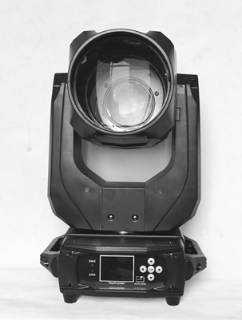

Please read over this manual before operation the light

CONTENTS

Chapter 1 Installation and attention 1
1. Maintenance 2
2. Statement 2
3. Safety Precaution 2
4. Product Instruction 错误！未定义书签。
5. Cable connection（DMX） 3
6. Rigging (Optional) 3
Chapter 2 Panel operation 4
1. Brief 4
2. Operation 错误！未定义书签。
3.Operation and parameter instruction 错误！未定义书签。
1.Set DMX Address 错误！未定义书签。
Chapter 3 Channel description 错误！未定义书签。
1. Channel table 7

Chapter 1 Installation and attention

Maintenance
- To reduce the risk of electrical shock or fire, do not expose this unit to rain or moisture.
- Intermittently using will extend this item’s service life.
- Please clear the fan ,fan net , and optical lens in order to keep good work state.
- Do not use the alcohol or any other organic solvent to wipe the shell.

Statement
The product has perfect performance and integrity packing. All users should be strictly complying with the warning and operating instructions as stated. Or we aren’t in charge of any result by misusing. Any damage resulting by misuse is not within the Company’s warranty. Any fault or problem caused by neglecting the manual is also not in the charge of dealers.
Note: All information is subject to change without prior notice.

Safety Precaution
- In order to guarantee the product’s life, please don’t put it in the damp places or even the environment over 60degress.
- Always mount this unit in safe and stable matter.
- Install or dismantle should operate by professional engineer.
- Using lamp，the change rate of power voltage should be within±10%，If the voltage is too high，it will shorten the light’s life; If it’s not enough, will influence the effect.
- Please restart it 20 minutes later after turning off light , until full-cooling. Frequent switching will reduce the life span of lamps and bulbs; intermittent using will improve the life of bulbs and lamps.
- In order to make sure the product is used well, please read the Manual carefully.
4.产品介绍
■定电压： AC110V-240V,50/60Hz
■光源规格：欧司朗 SIRIUS HRI 281
■光源寿命：2000H（灯泡和反光杯整体封装,光效更高使用寿命更长)
■色温： 8500K/4500K/3200K
■光束角度：平行光束角度0°~3.8°可调
■线性调光：机械线性调光0~100%，具有16Bit精度微调
■高速频闪：脉冲频闪，同步异步频闪. 频闪速度每秒0.5-11次/秒
■固定颜色： 1个固定颜色轮有13个色片,+白光， 可半色效果、线性色彩转换及双向变速旋转彩虹效果
■七彩颜色：七色效果
■静态图案： 1个固定图案盘有13个图案（含3个彩色玻璃图案）+空白，可图案抖动和流水效果
■棱镜： 2个独立的棱镜，旋转十六面棱镜+蜂窝棱镜，可叠加、双向旋转,旋转速度快慢可调，令图案投射效果更丰富
■调焦： 采用采用2组高精密玻璃光学镜头，电子线性高清调节，,能投射出高清的图案
■雾化： 1个独立的雾化效果，光斑柔和自然，柔光效果，轻松实现柔和梦幻的图案效果
■水平/垂直：水平扫描角度540°（16BIT精度扫描）,垂直扫描角度270°（16BIT精度扫描）,可自动纠错，采用三相电机不仅提供快速平滑扫描并消除传动噪音
■显示界面：液晶65万色触摸TFT界面，操作方便,界面美观,界面可180度反转显示
■智能散热：采用风向引流与温度智能监控技术，根据灯具不同位置的温度高低，自动驱动灯具里面不同部位的冷却风扇，对灯具部件进行有效的冷却
■智能灯泡开关控制 (延长灯泡使用寿命)
■国际标准控制信号：DMX512
■控制通道： 18CH
■防护等级： IP20

Cable connection（DMX）
Use a cable conforming to specifications EIA RS-485: 2-pole twisted, shielded, 120Ohm characteristic impedance, 22-24 AWG, low capacity. Do not use microphone cable or other cable with characteristics differing from those specified. The end connections must be made using XLR type 3 or 5-pin male/female connectors. A terminating plug must be inserted into the last projector with a resistance of 120Ohm (minimum 1/4 W) between terminals 2 and 3.
IMPORTANT: The wires must not make contact with each other or with the metal casing of the connectors. The casing itself must be connected to the shield braid and to pin 1 of the connectors.
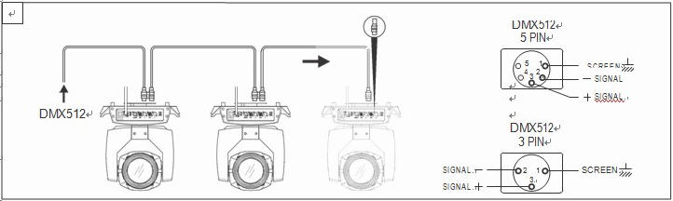

图1 DMX信号线连接示意图

Rigging (Optional)
This equipment can be positioned and fixed by clamp in every direction of the stage. Locking system makes it easy to fasten to the bracket.
Attention! Two clamps is needed to fix the equipment. Every clamp is locked by fastener of 1/4 kind. Fastener can only be locked clockwise.
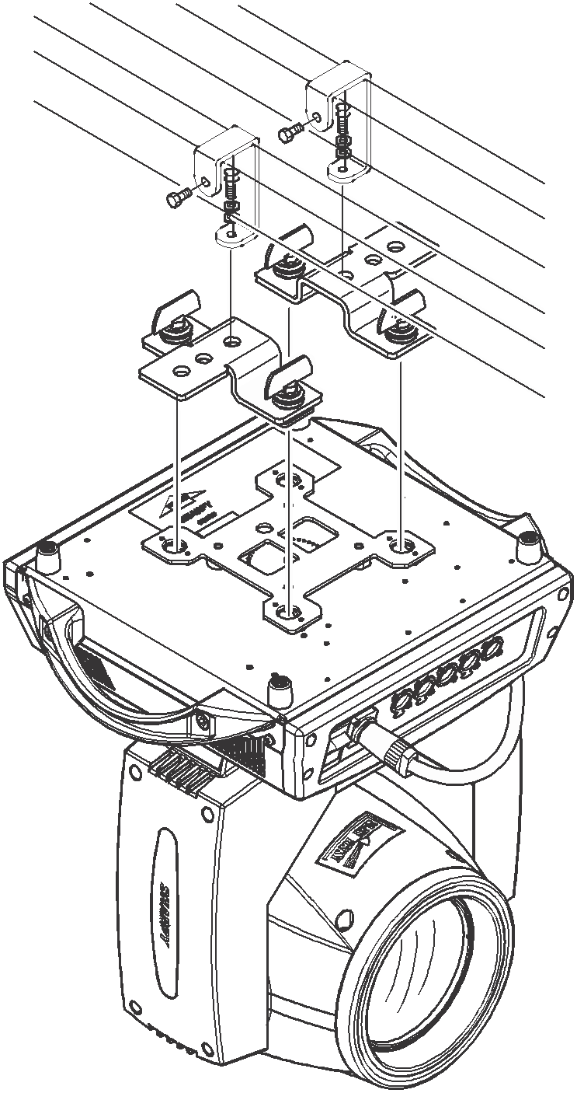
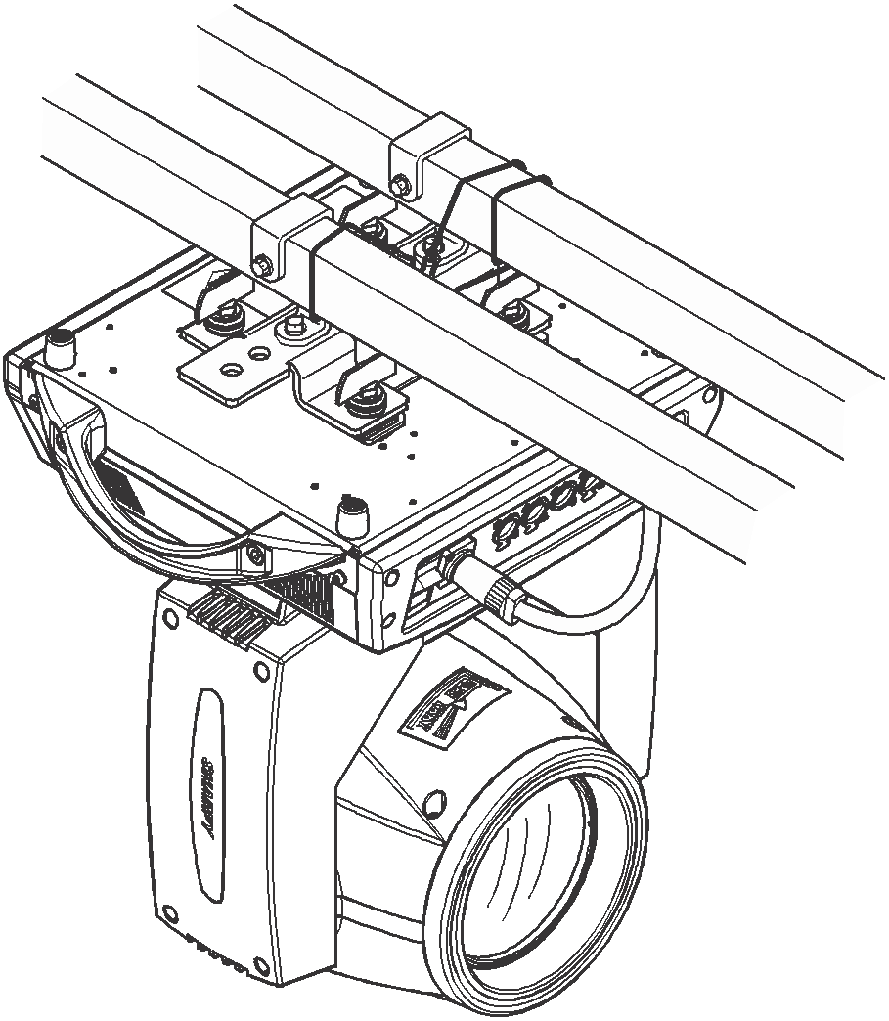
Attention! Fasten a safety string to the additional hole of side aluminum piece. The secondary accessory can not hang on the delivery handle. Nip the equipment on bracket.

Figure 2 Installation

Chapter 2 Panel operation

1.Brief
Display & operation just like ‘Android operation system’, touch the item will set or modify setting.
Note: Prevent damage the touch or TFT displayer, Can not use sharp objects chick displayer.
Key instructions:
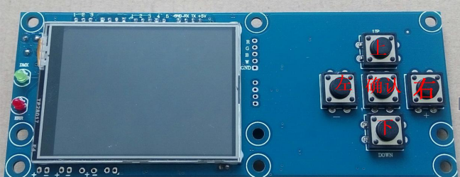

The "left" and "right" keys function the same way: return to
the previous interface
"Up" and "down" key: select and edit
"Determine" key (that is, "OK" key) : execute function, begin edit, exit edit
Main interface specification
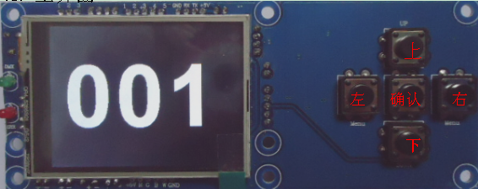

The following is an example of "modifying DMX address code" to describe the use of keys:
1. If it is not the main interface, press the "left" button (one or more times) to return to the main interface
2. Select the "Settings" button under the "upper" or "lower" keys under the main interface
Press "ok" to enter the "Settings" interface
4. Select the "DMX address" by pressing the "up" key or "under" key under the "setting" interface
Press "ok" to enter edit status
6. Modify the DMXDM address code by pressing "up" or "down" key
Press "ok" to exit edit status
If it's a touch screen, the process is more convenient:
1. Touch the "Settings" button in the main interface to enter the "Settings" interface
2. The same (both physical and touch-based buttons can be used) are the same as the previous 4-7 steps.

2. Set the interface
options | instructions
The operation mode | DMX |  | From the machine status: receiving DMX signal from the controller or host
The operation mode | automatic |  | Host: run automatically, and send the DMXD signal from machine
The operation mode | Voice control |  | Receiving external sound or vibration, run the built-in application effect
DMX address | 1-512 |  | Press "OK" button to enter edit state. At this point is selected to one hundred, according to the "up" "down"  Key change address code. Press the "OK" button once again and selected 10 editing. Press again  "OK" button to select bits editor. Then exit the editor state at a time.
The channel model | 16 |  | 17-20 channel is invalid
 | 20 |  | 17-20 channel control speed (see channel table)
X inversion | Guan/open
Y inversion | Guan/open
XY  The encoder | guan | Do not use the encoder (light coupling) correct position
XY  The encoder | op | Using encoder (light coupling) judging out-of-step and automatically correct position
No DMX signal | keep | According to the original state continues to run
No DMX signal | reset | The motor return, stop running
The screen saver | open | Close the backlit idle for 30 seconds
The screen saver | gua | Back lit yongliang
Switch on light bubble | open | When start the lamps and lanterns, lamp light up automatically
Switch on light bubble | guan | Start the lamps and lanterns, the bulb is not bright
Restore the default Settings | no
Restore the default Settings | yes | Press "ok" is to restore the default Settings

3. Information interface
options | instructions

Software version | The current software version
A total of time | Cumulative time (accurate to minutes)
The use of time | The use of this boot since time (down to minute)
Total light soaking time | Total light bubble time (accurate to minutes)
The light soaking time | The light of this boot since bubble time (down to minute)
DMX channel value | In the condition of DMX, showing all channels of value (number),  thus the child into the interface, display as a percentage value and channel value for viewing
System error record | If red ERR lights shine, then failed to reset  run out of step, can enter child interface for details. After the view can press "ok" the error record to empty
4.Manual control interface
This interface is used to control the current lamps and lanterns, neither belongs to the state machine from machine shape (not receiving DMX signal) also does not belong to the host shape (not send DMX signal)
options | instructions
reset | Click "ok" button after see confirmation dialog, press the "ok" key once again, after carry into the interface, reset all motor
The light bulb control | Open/guan
The color wheel | 0-255 | Press "ok" button to enter edit state. At this point is selected, click on "next" button to change channels values, press the "ok" button once again and exit the editor.
。。。。。。 | 0-255
Pattern plate speed | 0-255

5. Advanced interface
To enter the show advanced interface, please enter the password: XXXXXX. Specific operation process: press the up and down key to choose Numbers (a *) at a time. Password input after fully, finally press the "ok" key password authentication.
options | instructions
The biggest bright time | 0-9999 | Can be set up on time
Encryption scheme | guan
Encryption scheme | The number of | Can be set up the use of lamps and lanterns
Encryption scheme | time | Can install the use time of lamps and lanterns
Encryption parameters (frequency/time) | 0-9999 | After the encryption mode to open the work. Can be set up the use of lamps and lanterns (number/time)

6. Thou hast interface
Click "ok" button, the interface inversion can be 180 degree show.

7. English interface
Click "ok" button, the interface, switch to English mode.

8. Chinese interface
Click "ok" button, the interface, switch to the Chinese model.

9. The factory interface
Enter the factory interface, display, please enter the password: XXXXXX. Specific operation process: press the up and down key to choose Numbers (a *) at a time. Password input after fully, finally press the "OK" (OK) key password authentication.
options | instructions
Reset the calibration (fine) | 0-255 | X calibration
Reset the calibration (fine) | 0-255 | Y calibration
Reset the calibration (fine) | 0-255 | The dimming calibration
Reset the calibration (fine) | 0-255 | Color wheel alignment
Reset the calibration (fine) | 0-255 | Pattern plate of the calibration
Reset the calibration (fine) | 0-255 | Focusing calibration
Reset the calibration (fine) | 0-255 | Prism calibration
Reset the calibration (fine) | 0-255 | Fog lens calibration
Channel Settings | Can be set up channel switch
Screen saver mode | Pattern 1 | According to address code
Screen saver mode | Pattern 2 | According to factory LOGO
Screen saver mode | Pattern 3 | No display (reserve)
Bright time reset | NO/YES

Chapter 3Channel table

DMX Channel List
CH | Eng contrast | DMX | English
1 | Colour | 0 - 9 | Colour1
1 | Colour | 10 - 14 | Colour1+Colour2
1 | Colour | 15 - 19 | Colour2
1 | Colour | 20 - 24 | Colour2+Colour3
1 | Colour | 24 - 29 | Colour3
1 | Colour | 30 - 34 | Colour3+Colour4
1 | Colour | 35 - 39 | Colour4
1 | Colour | 40 - 44 | Colour4+Colour5
1 | Colour | 45 - 49 | Colour5
1 | Colour | 50 - 54 | Colour5+Colour6
1 | Colour | 55 - 59 | Colour6
1 | Colour | 60 - 64 | Colour6+Colour7
1 | Colour | 65 - 69 | Colour7
1 | Colour | 70 - 74 | Colour7+Colour8
1 | Colour | 75 - 79 | Colour8
1 | Colour | 80 - 84 | Colour8+Colour9
1 | Colour | 85 - 89 | Colour9
1 | Colour | 90 - 94 | Colour9+Colour10
1 | Colour | 95 －99 | Colour10
1 | Colour | 100－104 | Colour10+Colour11
1 | Colour | 105－109 | Colour11
1 | Colour | 110－114 | Colour11+Colour12
1 | Colour | 115－119 | Colour12
1 | Colour | 120－124 | Colour12+Colour13
1 | Colour | 125－129 | Colour13
1 | Colour | 130－134 | Colour13+Colour14
1 | Colour | 135－139 | Colour14
1 | Colour | 140－149 | Colour14+Colour1
1 | Colour | 150－203 | Forward flow( From fast to slow )
1 | Colour | 204－255 | Reverse flow( From slow to fast)
2 | Shutter | 0－3 | Closed
2 | Shutter | 4－103 | Strobe pulse( From slow to fast)
2 | Shutter | 104－107 | Open
2 | Shutter | 108－207 | Stroboscopic effect( From slow to fast)
2 | Shutter | 209－212 | Open
2 | Shutter | 213－251 | Randomstrobe( From slow to fast)
2 | Shutter | 252-255 | Open
3 | Dimmer | 0-255 | From dark to light
4 | Gobo | 0 - 5 | Gobo1
4 | Gobo | 6 - 11 | Gobo2
4 | Gobo | 12 - 17 | Gobo3
4 | Gobo | 18 - 23 | Gobo4
4 | Gobo | 24 - 29 | Gobo5
4 | Gobo | 30 - 35 | Gobo6
4 | Gobo | 36 - 41 | Gobo7
4 | Gobo | 42 - 47 | Gobo8
4 | Gobo | 48 - 53 | Gobo9
4 | Gobo | 54 - 59 | Gobo10
4 | Gobo | 60 - 65 | Gobo11
4 | Gobo | 66 - 71 | Gobo12
4 | Gobo | 72 - 77 | Gobo13
4 | Gobo | 78 - 83 | Gobo14
4 | Gobo | 84 - 89 | Gobo15
4 | Gobo | 90－134 | Forward flow( From fast to slow )
4 | Gobo | 135－139 | Gobo1
4 | Gobo | 140－185 | Reverse flow( From slow to fast)
4 | Gobo | 186－190 | Gobo2 Jitter( From slow to fast)
4 | Gobo | 191－195 | Gobo3 Jitter( From slow to fast)
4 | Gobo | 196－200 | Gobo4 Jitter( From slow to fast)
4 | Gobo | 201－205 | Gobo5 Jitter( From slow to fast)
4 | Gobo | 206－210 | Gobo6 Jitter( From slow to fast)
4 | Gobo | 211－215 | Gobo7 Jitter( From slow to fast)
4 | Gobo | 216－220 | Gobo8 Jitter( From slow to fast)
4 | Gobo | 221－225 | Gobo9 Jitter( From slow to fast)
4 | Gobo | 226－230 | Gobo10 Jitter( From slow to fast)
4 | Gobo | 231－235 | Gobo11 Jitter( From slow to fast)
4 | Gobo | 236－240 | Gobo12 Jitter( From slow to fast)
4 | Gobo | 241－245 | Gobo13 Jitter( From slow to fast)
4 | Gobo | 246－250 | Gobo14 Jitter( From slow to fast)
4 | Gobo | 251－255 | Gobo15 Jitter( From slow to fast)
5 | Prism1 | 0 -127 | Prism1 pop up
5 | Prism1 | 128-255 | Prism1 cut
6 | Prism1 Rot | 0 － 64 | Rotation
6 | Prism1 Rot | 65 -127 | Forward flow( From slow to fast)
6 | Prism1 Rot | 128-191 | Reverse flow( From slow to fast)
6 | Prism1 Rot | 192-255 | Positive and negative rotatio( From slow to fast)
7 | Prism2 | 0 -127 | Prism2 pop up
7 | Prism2 | 128-255 | Prism2 cut
8 | Prism2 Rot | 0 － 64 | Rotation
8 | Prism2 Rot | 65 -127 | Forward flow( From slow to fast)
8 | Prism2 Rot | 128-191 | Reverse flow( From slow to fast)
8 | Prism2 Rot | 192-255 | Positive and negative rotatio( From slow to fast)
9 | Focus | 0-255 | Linear focus( From near to far)
10 | Pan | 0 －255 | 0-540 Degree
11 | Pan Low | 0 －255 | 0-2.1 Degree Low
12 | Tilt | 0 －255 | 0-270 Degree
13 | Tilt Low | 0 －255 | 0-2.1 Degree Low
14 | P/T Speed | 0 －255 | From fast to slow
15 | Frost | 0 -255 | Frost
16 | qicai | 0-127 | Qicai pop up
16 | qicai | 128-255 | Qicai cut
17 | Lamp | 0 －99 | invalid
17 | Lamp | 100－105 | Lamp Off
17 | Lamp | 106－199 | invalid
17 | Lamp | 200－205 | Lamp On
17 | Lamp | 206－255 | invalid
18 | Reset | 0-249 | invalid
18 | Reset | 250－255 | Reset

